// Question 1

function question1(inputData) {

const data = Object.keys(inputData).map((key) => {

let newObj = {};

newObj[key] = inputData[key];

return newObj;

});

console.log(data);

}

question1({ a: 1, b: 2, c: 3 });

output:

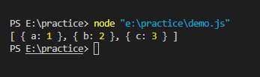

// Question 2

function question2(inputData) {

const newObj = {};

inputData.forEach((item) => {

newObj[Object.keys(item)[0]] = item[Object.keys(item)[0]];

});

console.log(newObj);

}

question2([{ a: 1 }, { b: 2 }, { c: 3 }]);

Output:

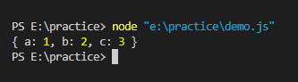

// Question 3

"use strict";

const fs = require("fs");

process.stdin.resume();

process.stdin.setEncoding("utf-8");

let inputString = "";

let currentLine = 0;

process.stdin.on("data", function (inputStdin) {

inputString += inputStdin;

});

process.stdin.on("end", function () {

inputString = inputString.split("\n");

main();

});

function readLine() {

return inputString[currentLine++];

}

//Main solution

**function handshake(n) {**

**// Write your code here**

**if (n == 1) {**

**return 0;**

**} else {**

**var sum = 0;**

**for (var i = 0; i < n; i++) {**

**sum += i;**

**}**

**return sum;**

**}**

**}**

function main() {

const ws = fs.createWriteStream(process.env.OUTPUT_PATH);

const t = parseInt(readLine().trim(), 10);

for (let tItr = 0; tItr < t; tItr++) {

const n = parseInt(readLine().trim(), 10);

const result = handshake(n);

ws.write(result + "\n");

}

ws.end();

}

//Output

